# Deploy wordpress with amazon RDS

Lab1: creating a MYSQL database with RDS

* Click the orange create database button to get started

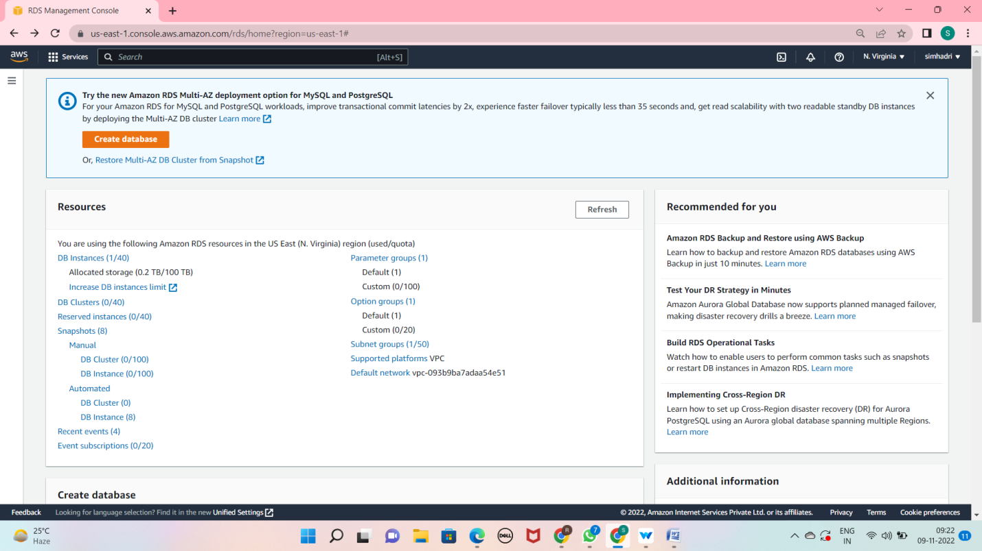

* Press wordpress uses MYSQL engine now

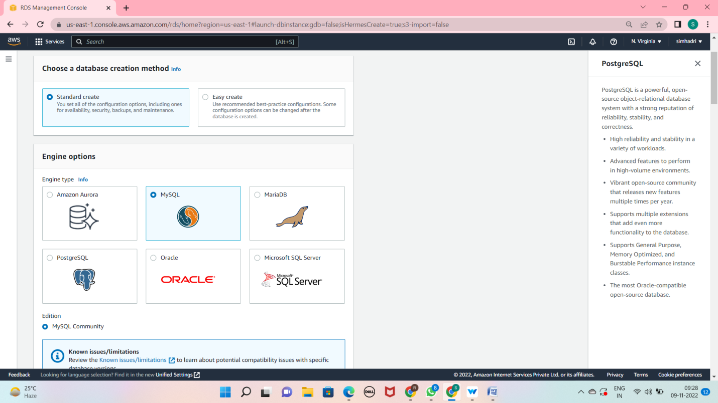

* Now press free tier template

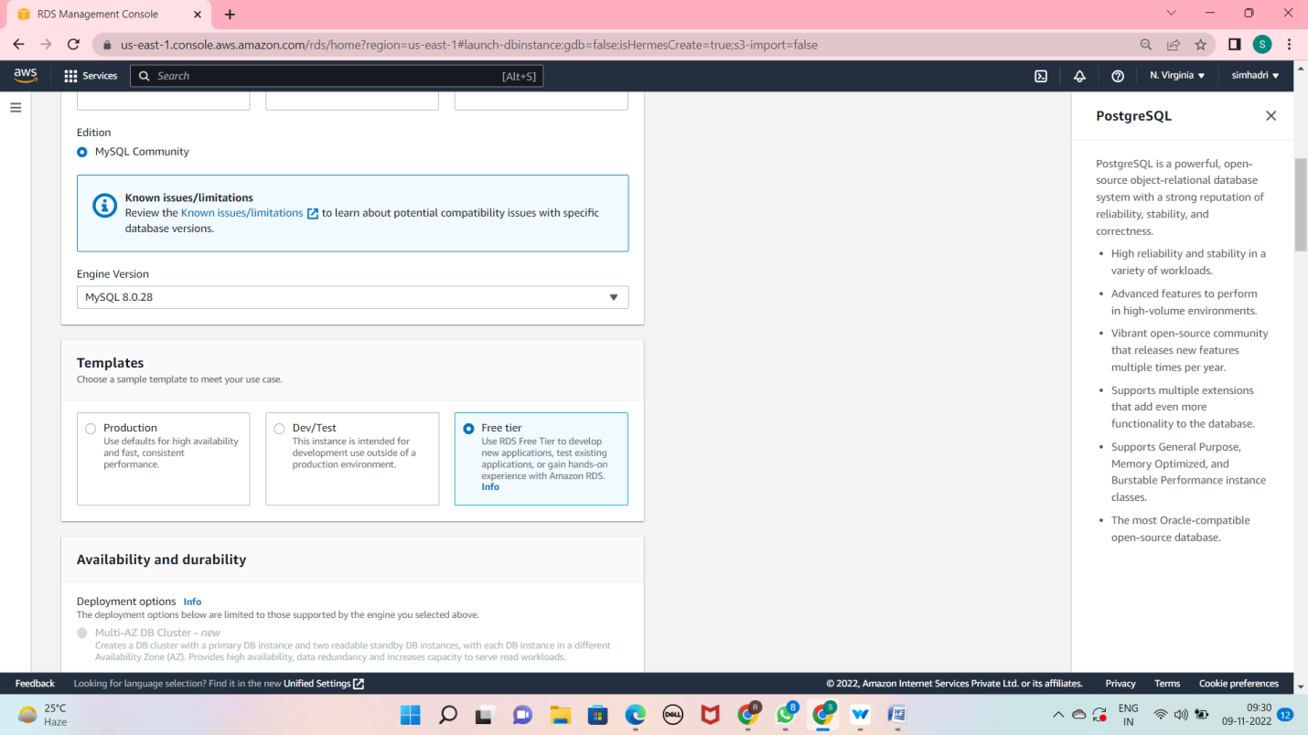

* Give database instance identifier and username and password

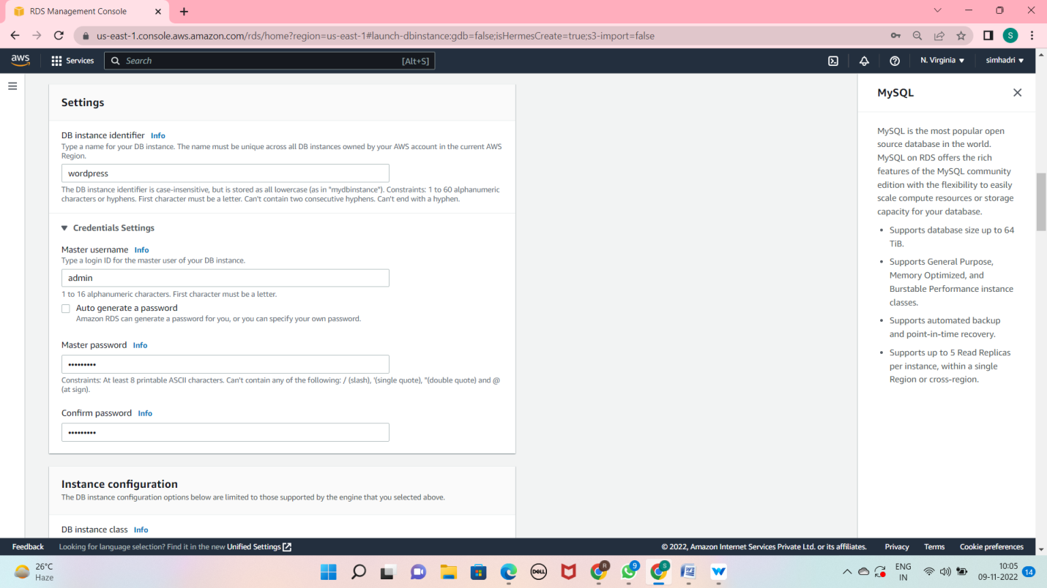

* Use db.t2.micro

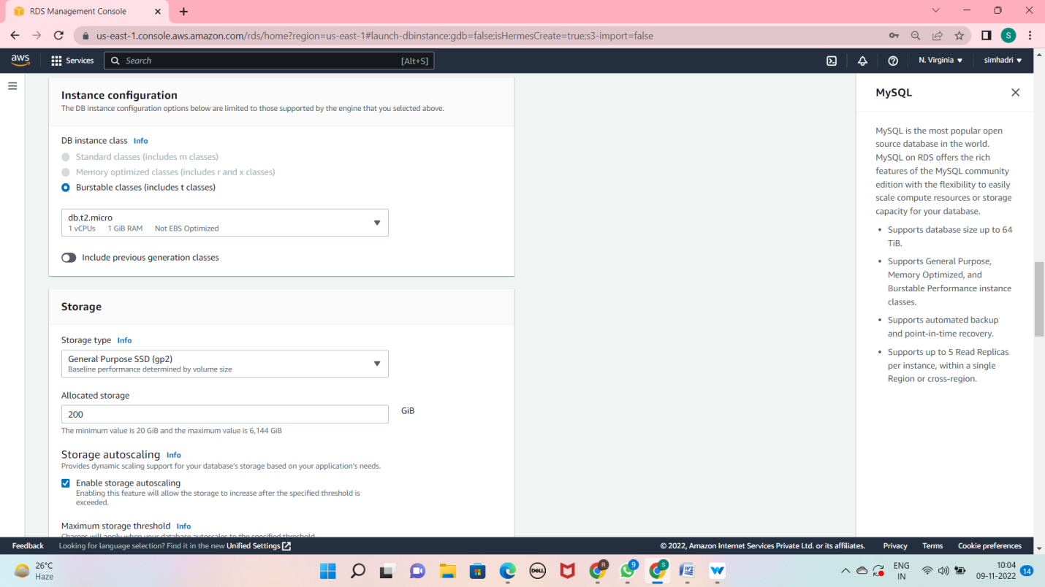

* Press additional settings
* Give initial database name

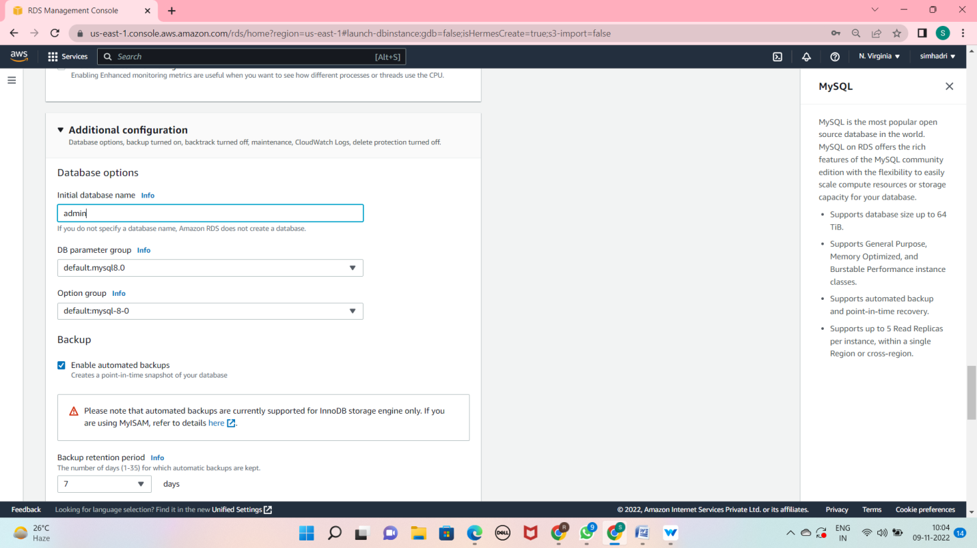

* Press create database

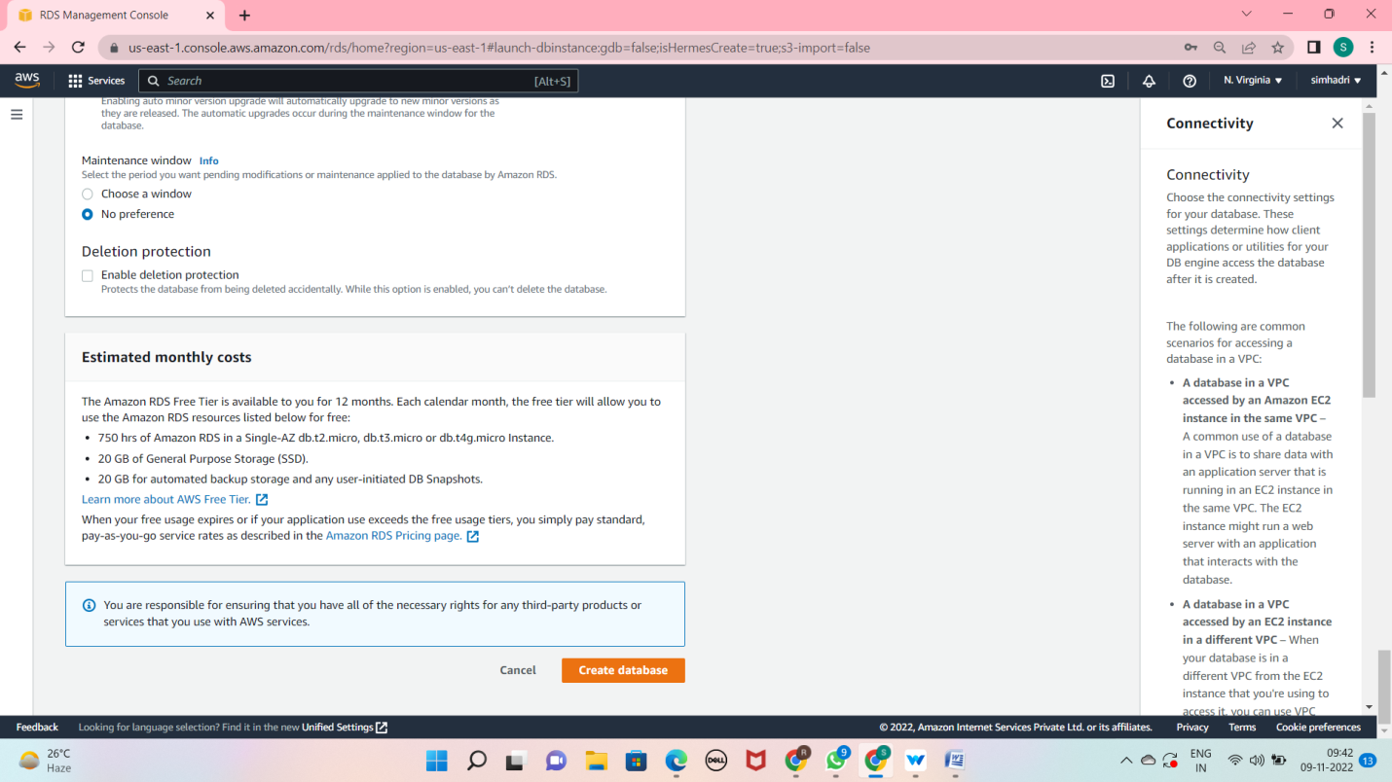

* You should see a success notice indicating that your database is being created

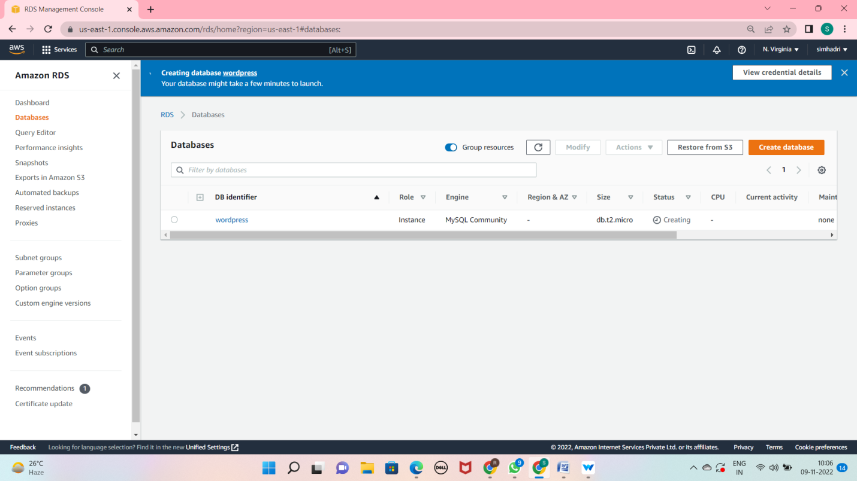

## Lab2: creating an EC2 instance to run wordpress site

* First launch instance
* Review and launch

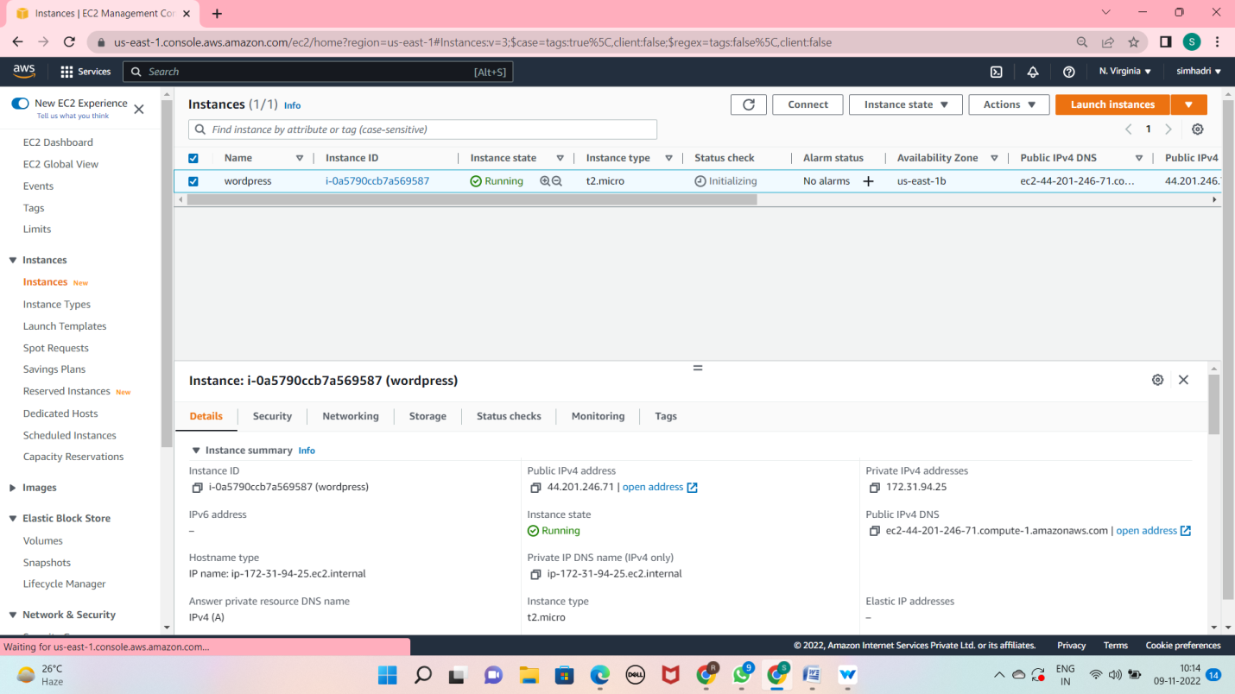

Lab3: configuring your RDS database

* Allow your ec2 instance to access your rds databse

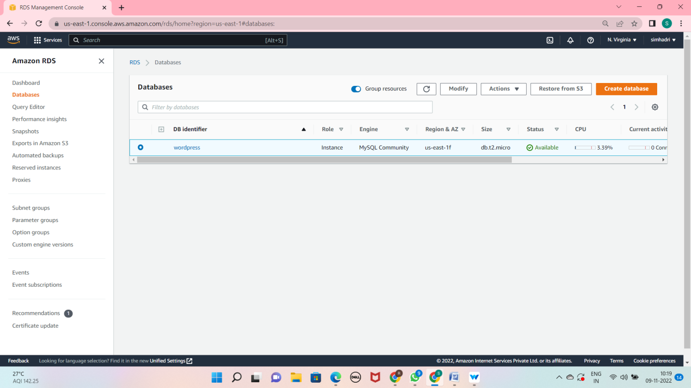

* Scroll to the connectivity and security tab in the display, and click on the security group listed in VPC security groups.

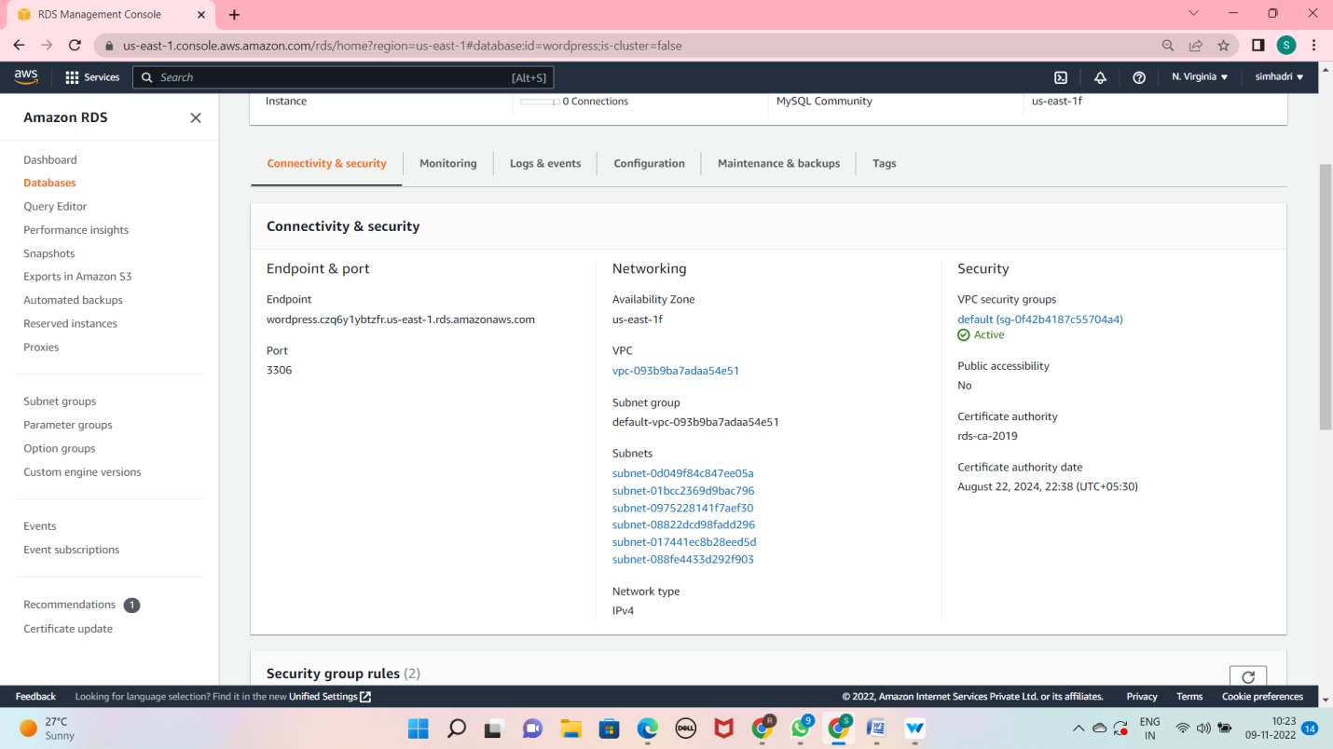

* The console wil take you to the security group configured for your databse.
* Click inbound tab, then click the edit button to change the rules for your secutity group.

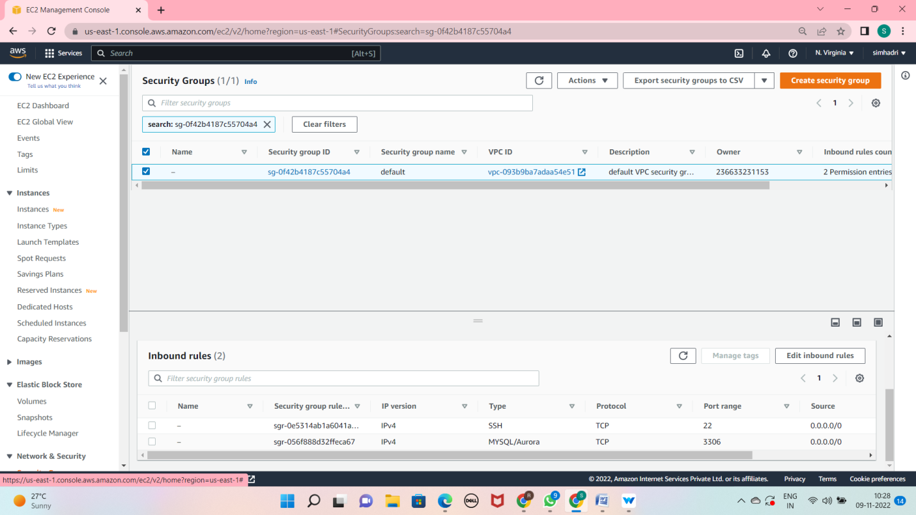

* The default security group has a rule that allows all inbound traffic from other instances in the

Default security group.

* The default security group has a rule that allows all inbound traffic from other instances in the

Access the rds database

* Change the Type property to MYSQL/Aurora, which will update the Protocol and Port Range to

The proper values.

* remove the security group
* add wordpress security group

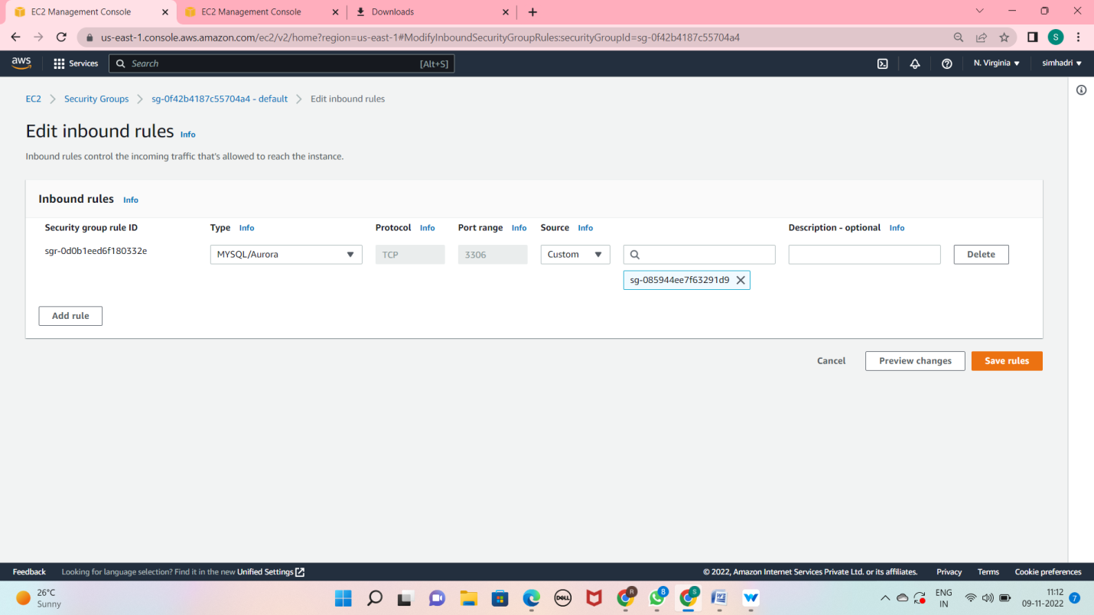

* ssh into connect ec2 instance

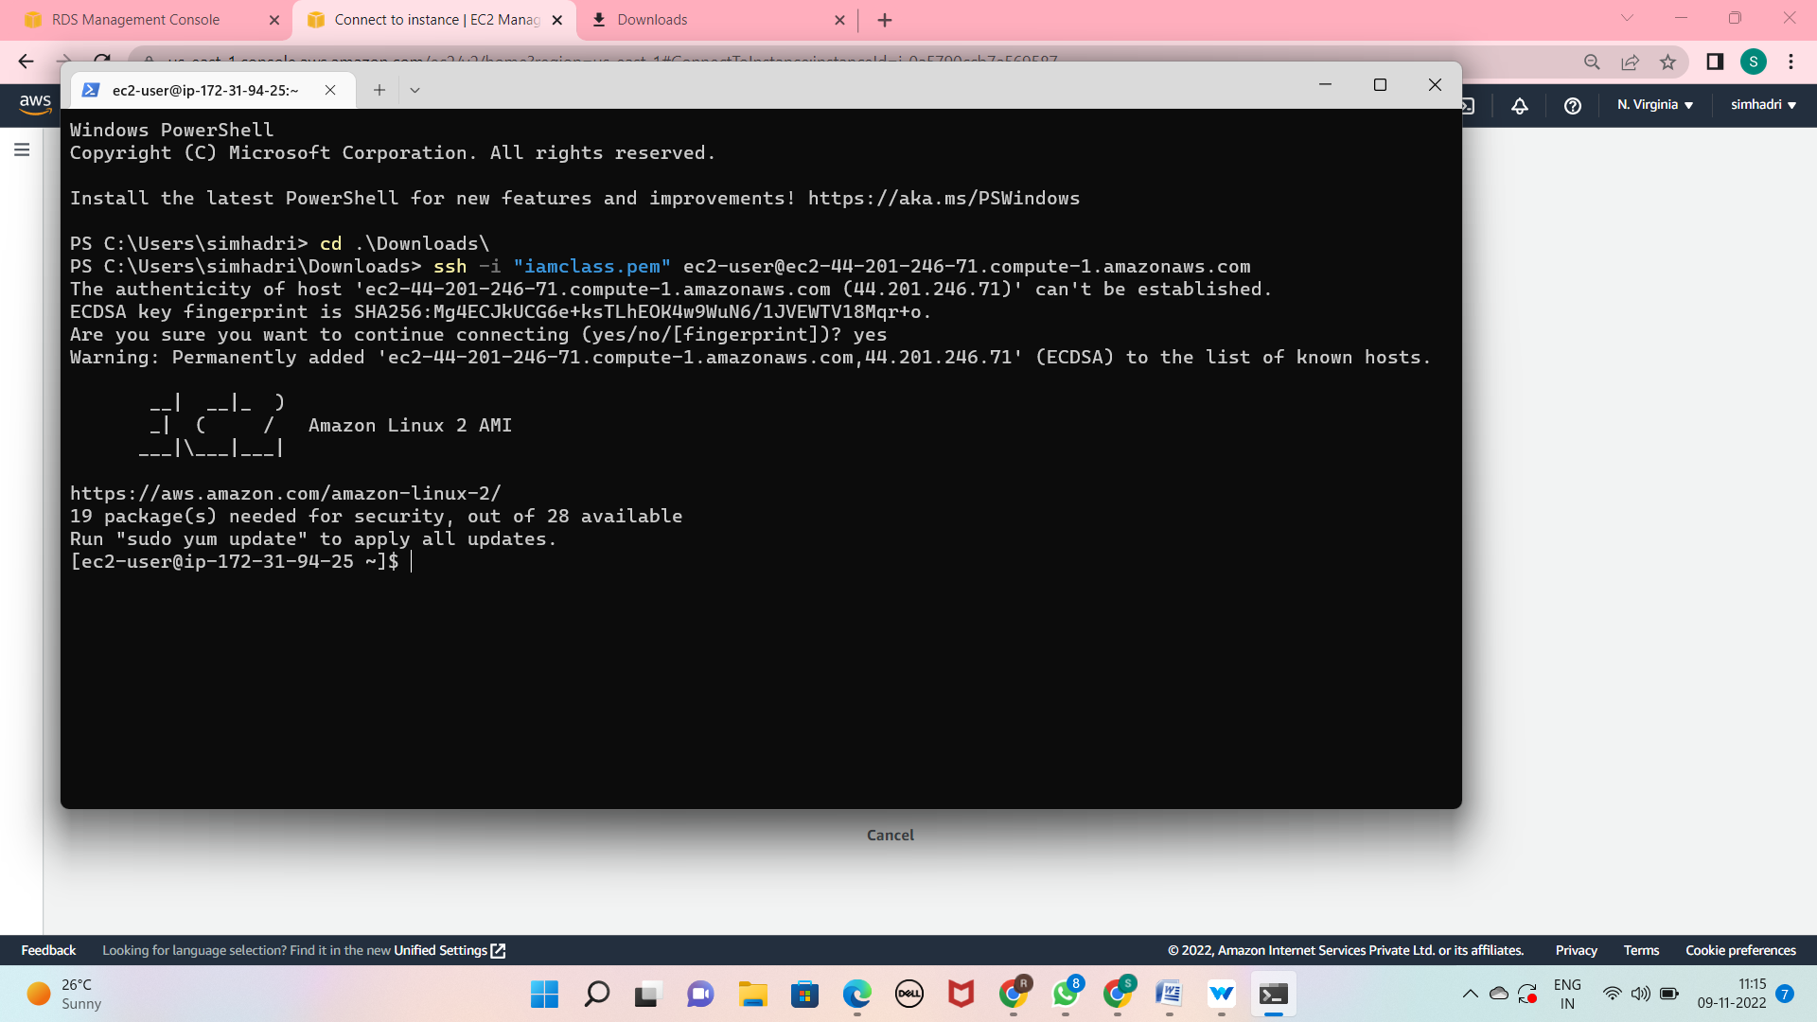

* create a databse user
* Sudo yum –y install mysql
* 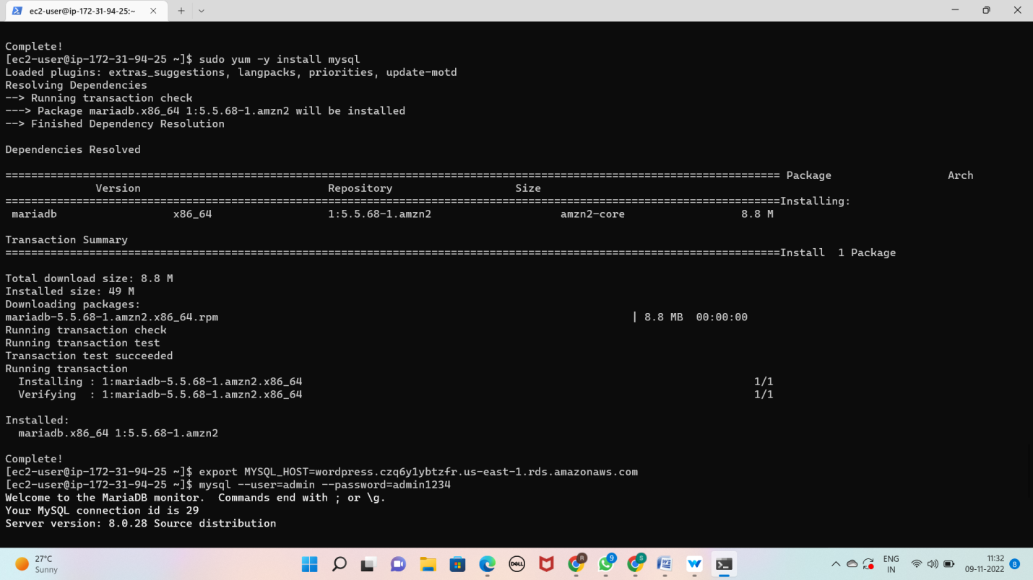
* export MYSQL_HOST=<use rds endpoint>

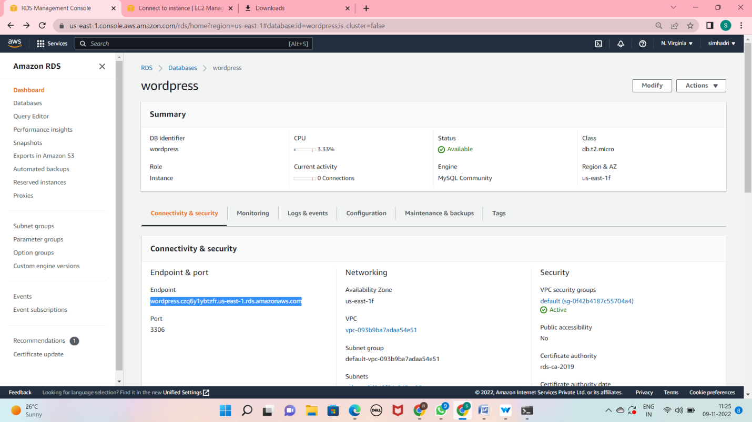

* mysql --user= username –password=
* CREATE USER 'wordpress' IDENTIFIED BY 'wordpress-pass';
* GRANT ALL PRIVILEGES ON wordpress.* TO wordpress;
* FLUSH PRIVILEGES;
* EXIT

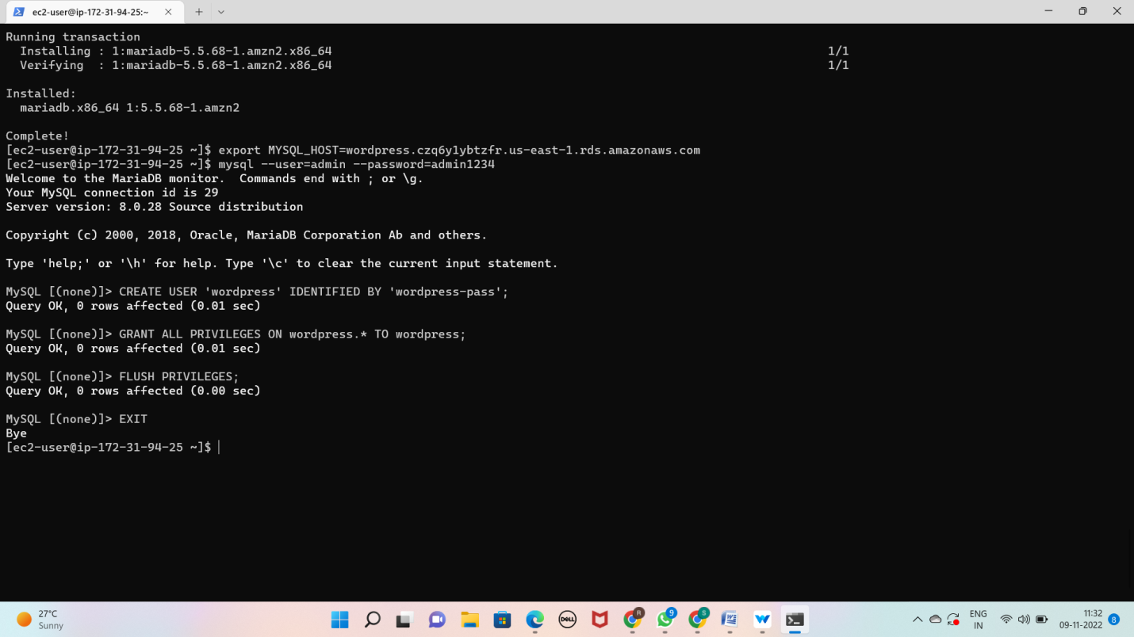

# Lab4: configuring wordpress on ec2

* Installing the Apache Web Server
* To install Apache on your EC2 instance, run the following command in your terminal
* sudo yum install -y httpd
* To start the Apache web server, run the following command in your terminal
* sudo service httpd start
* go to ec2 instance page see the public dns ipv4 code and paste it on browse then u see this page

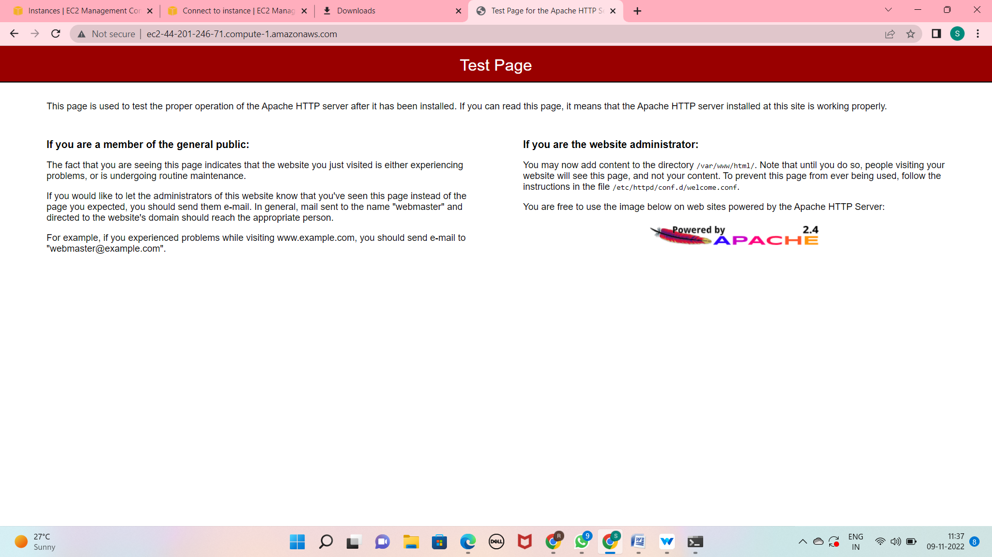

* download and configure wordpress
* First, download and uncompressing the software by running the following commands in your terminal

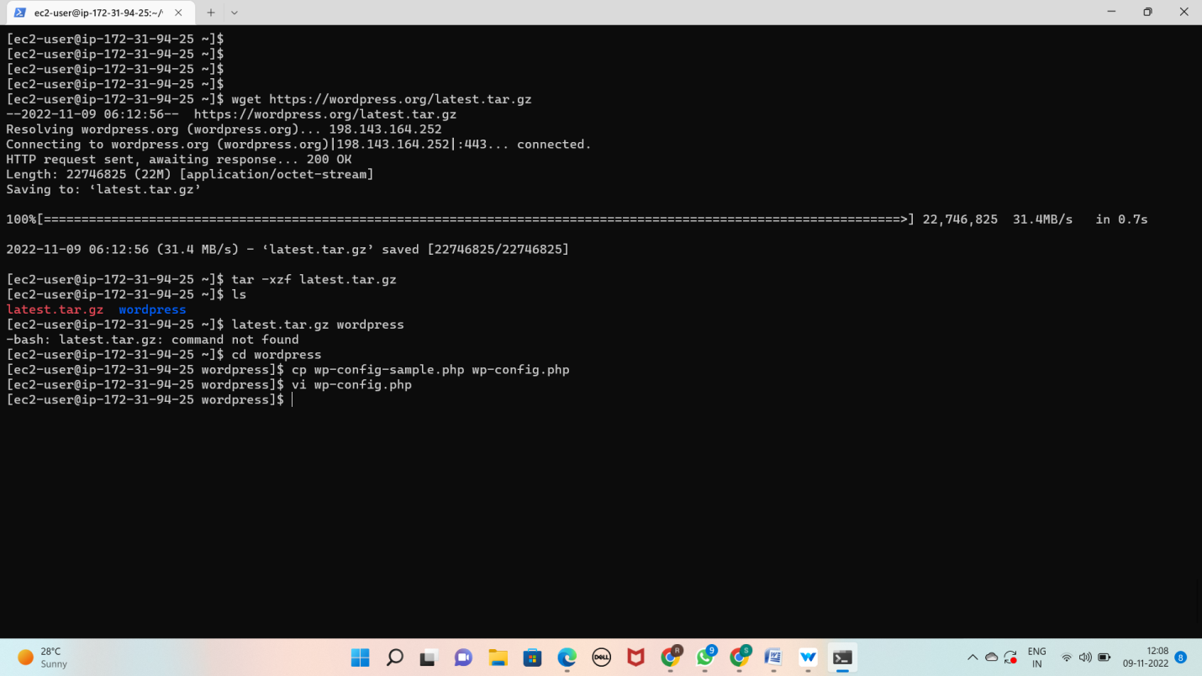

# Deploying wordpress site

* First, install the application dependencies you need for WordPress. In your terminal, run the

Below command

sudo amazon-linux-extras install -y lamp-mariadb10.2-php7.2 php7.2

* Now change the proper directory

cd /home/ec2-user

* Then, copy your WordPress application files into the /var/www/html directory used by apache

sudo cp -r wordpress/* /var/www/html/

* Finally, restart the Apache web server to pick up the changes

sudo service httpd restart

* You should see the WordPress welcome page and the five-minute installation process

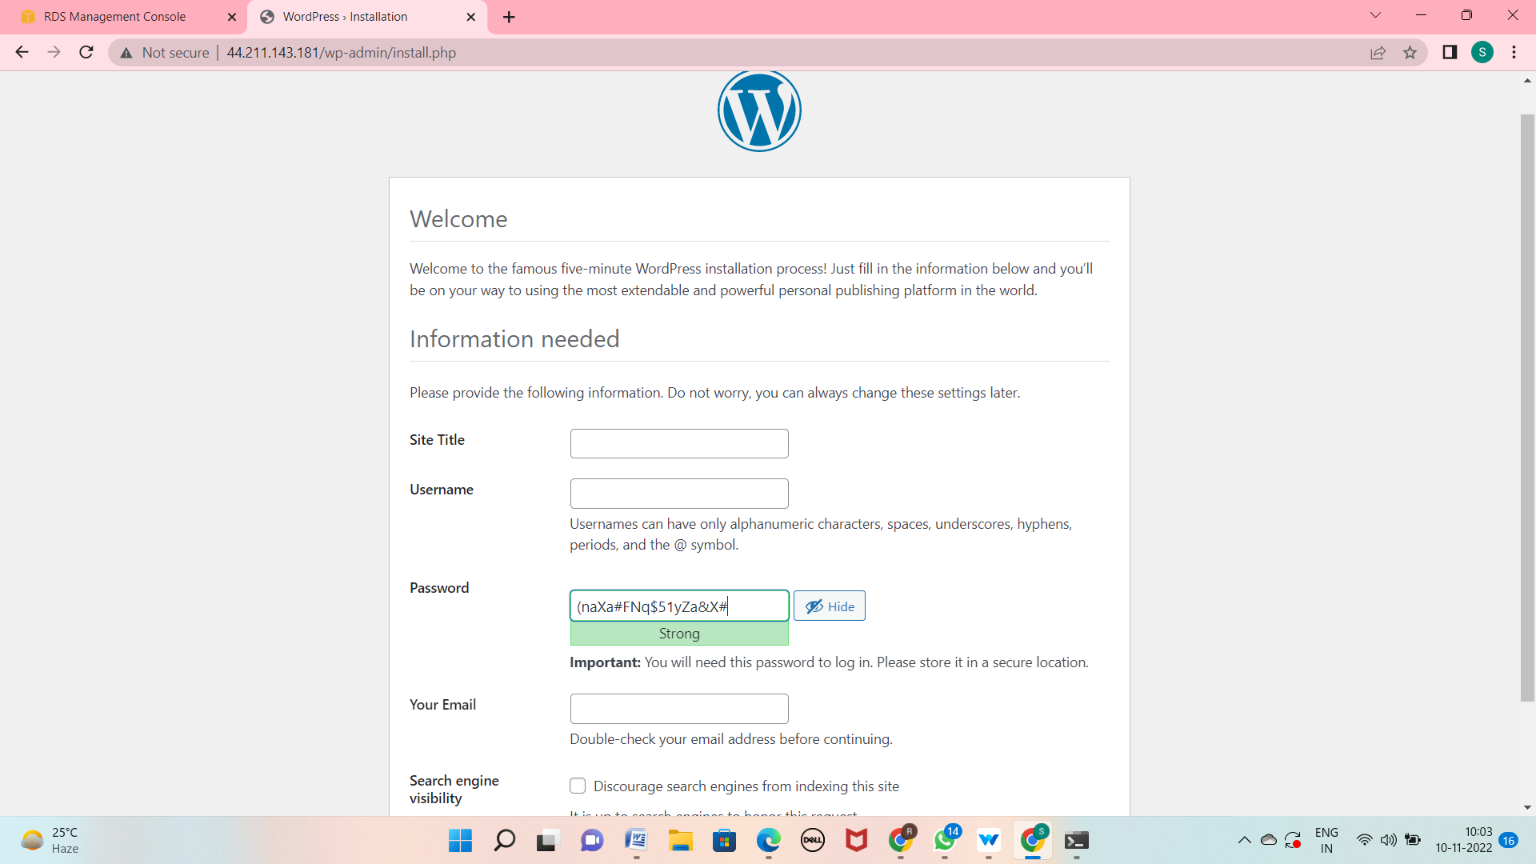

# Lab5: explore our new website and do clean up activity

Clean up the resources created in the lab:

a. Remove your EC2 Instance

b. Delete your RDS Instance

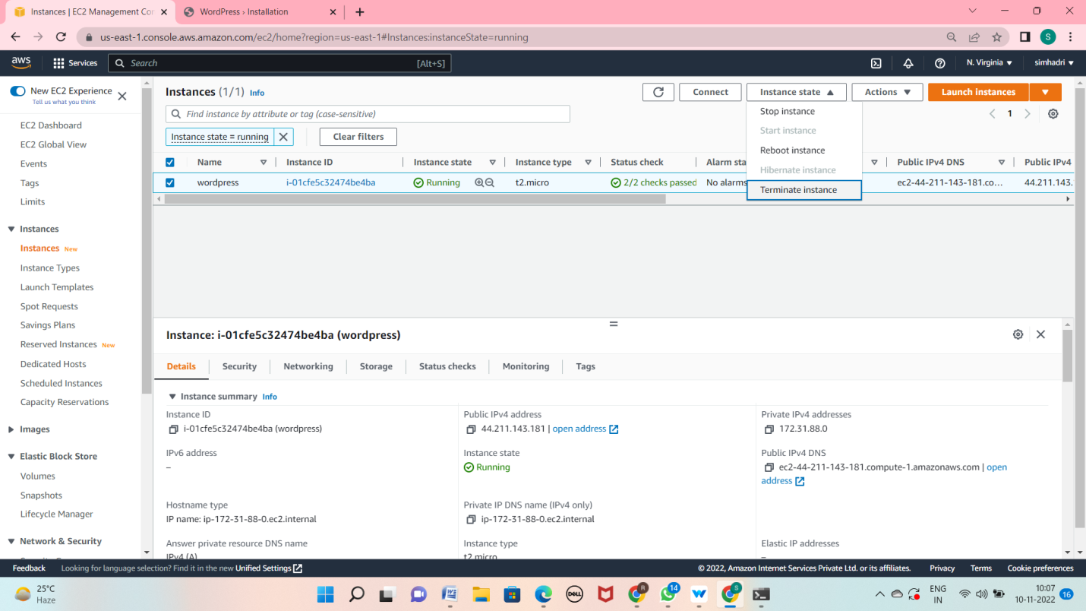

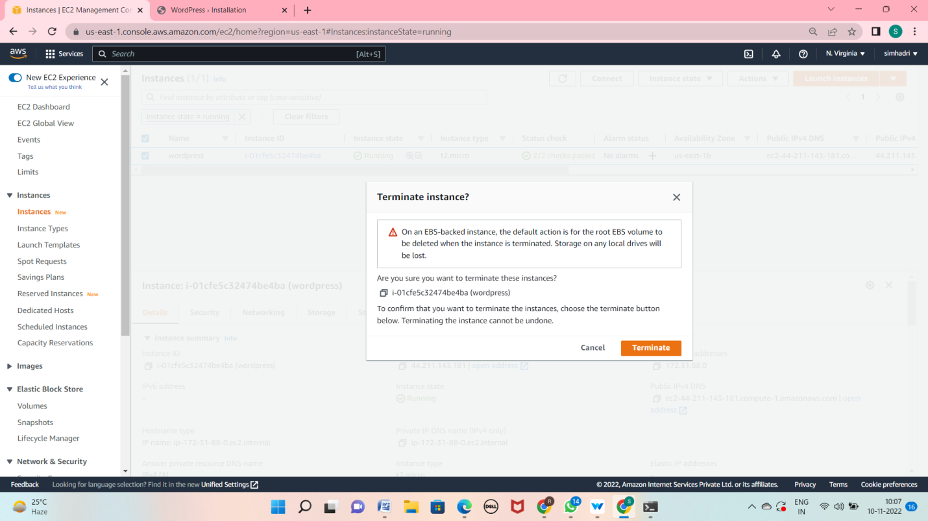

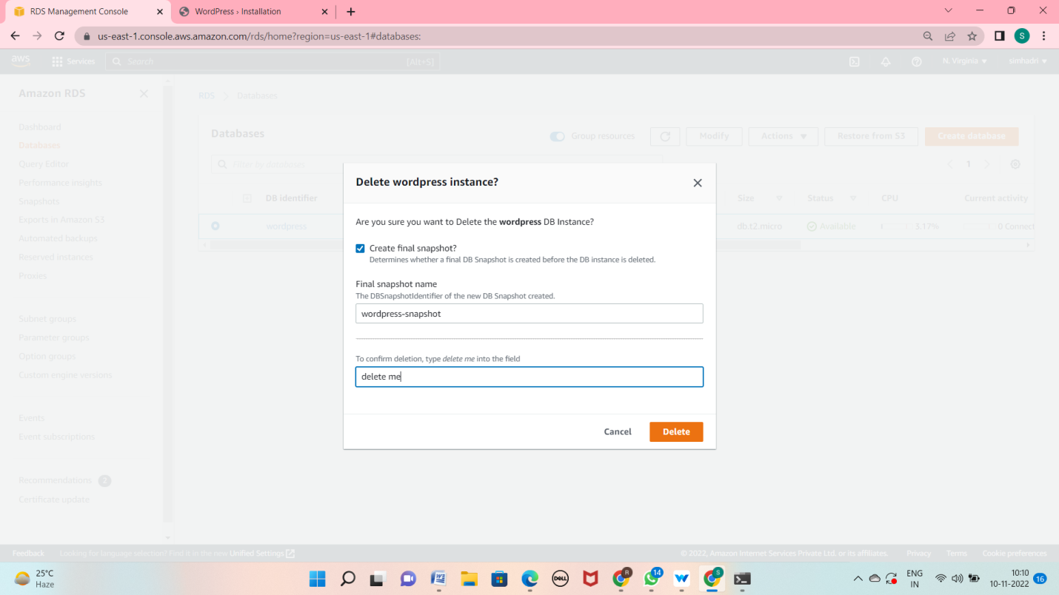

Now cleared all

Thank you

K simhadri